Cover Page

Module:
MBA7068 Academic Skills and Professional Practice
Assessment: Assignment 1 Portfolio
Title: “The Impact of Artificial Intelligence Adoption on Organisational Productivity and Workforce Transformation in Global Businesses”
Student Number:
Tutor Name:
Submission Date:
Word Count:

Table of Contents
TASK 1: AI Adoption impact on Organisational Productivity & Workforce Transformation in Global Businesses 3
1.0 Introduction 3
2.0 Research Background and Rationale 3
3.0 Research Aim 4
4.0 Research Questions 4
5.0 Research Objectives 4
6.0 Literature Review 4
6.1 Conceptualising Artificial Intelligence 5
6.2 AI and Organisational Productivity 5
6.3 Workforce Transformation 6
6.4 Relevant Theories 6
7.0 Data Sources and Research Design 8
8.0 Conclusion 8
TASK 2: Critical Reflection on Academic Skills and Professional Identity 9
1.0 Introduction 9
2.0 Reflective Framework 9
3.0 Self-Evaluation 10
4.0 Skills Development 10
5.0 Personal Development Plan 11
6.0 Conclusion 12
References 13

TASK 1: AI Adoption impact on Organisational Productivity & Workforce Transformation in Global Businesses

1.0 Introduction
Artificial Intelligence has become an important part of modern day businesses. It has brought significant digital transformation in businesses. Using AI, businesses have been able to improve operations and customer services. AI technologies help with better analytics and prediction of market trends to help business designing marketing strategies (Jiang et al., 2022). There are various AI based technologies like machine learning, predictive analytics and generative AI that helps in organizational performances. The adoption of AI is significantly higher among the large business organizations due to their ability to make high initial investment. The IBM Global AI adoption index 2024 found that 43% of large organizations across the world have adopted AI. The features of AI have influenced the businesses to incorporate AI. AI has brought automation in organizations to improve the operational functioning (Stone et al., 2022). The organizations have been able to avoid repetitive tasks with the incorporation of AI. The integration of AI in business has also raised concern regarding the ethical issues as well as risks of job displacement. The employees can also become a resistance factor behind the integration of AI.

2.0 Research Background and Rationale
The integration of AI has changed the dynamics of business operations. AI has introduced automation and analytics to improve the operational performances. Using AI, businesses are analysing vast volumes of data to analyse market trends and customer preferences. The designing of marketing campaigns has been simplified for the businesses as AI is helping to explore the market trends as well as consumer behaviour (Enholm et al., 2022). Customer services of the companies have changed with the introduction of AI features like chatbot. It has replaced human resources with technologies to support customer services. The growth of AI is expected to have a significant impact on the market in coming years. An estimation shows that the industry can make a contribution of more than $ 15 trillion USD by 2030 (Perifanis and Kitsios, 2023). However, the ethical implication of AI uses remains a concern. This is because AI could make biassed decisions as well as replace human jobs. It can create a significant issue of unemployment in the coming future.

3.0 Research Aim
This research has the aim to evaluate the impact that AI has upon the changing workforce along with the increasing productivity within the contemporary multinational business. Additionally, this research will also analyse the potential challenges as well as opportunities related with the adoption of AI within the global contemporary business.

4.0 Research Questions
- What is the extent of AI adoption within the global business organisations and its usage for enhancing the organisational operations ?
- What is the impact of AI adoption upon the organisational productivity and workforce transformation within the multinational business?
- What are the strategic implications, key opportunities and challenges which are associated with AI implementation in the global organisations ?

5.0 Research Objectives
- To analyse the extent of AI adoption within the global business organisations and its usage for enhancing the organisational operations
- To assess the impact of AI adoption upon the organisational productivity and workforce transformation within the multinational business
- To identify strategic implications, key opportunities and challenges which are associated with AI implementation in the global organisations

6.0 Literature Review
AI has become a common phenomenon in the contemporary business world. AI is a technology based on a computer system that is capable of performing tasks that were majorly done using human intelligence. In accordance with Sestino and De Mauro (2022), AI includes technologies like deep learning, machine learning, and natural language processing. In recent times, generation AI has also become a major development with the introduction of platforms such as Chatbot, Gemini, and Claude. Using generative AI, businesses are creating visual graphics for the marketing campaigns. The adoption of AI is significantly higher among the large organizations due to the need of initial costs (Loureiro et al., 2021). However, the high initial cost of AI implementation is restricting small and medium size businesses with low value to implement AI. However, generative AI offers low-cost value which is attracting the SMEs to integrate AI. The report by Statista claims that the global AI market is expected to reach $826 billion USD by 2030. However, researchers like Bharadiya (2023), raised concern regarding the potential negative impacts of AI adoption. According to the researcher, AI adoption can lead to significant loss of human jobs as well as ethical issues in decision making.

6.1 Conceptualising Artificial Intelligence
Integration of AI in business has changed the process of work by bringing automation. It has replaced human resources to improve efficiency of repetitive tasks. Along with this, AI has also helped businesses to analyse large volumes of data for designing the marketing strategies. By using AI, businesses have been able to reduce faults. The use of predictive analytics has helped in identifying potential issues before their occurrences to solve the problems. The major MNCs to use AI in business are Google, Amazon, Microsoft. Using AI, these companies have been able to reduce dependence on human resources. Also, it has provided the opportunity to solve basic customer issues using AI platforms. AI is also expected to cause significant reduction in the number of human resources and potentially create an employment crisis (Bharadiya et al., 2023). The labour intensive industries with a huge number of human resources can face the challenge in integrating AI. This is because the companies can encounter organizational strategies of AI adoption in business.

6.2 AI and Organisational Productivity
With the adoption of AI, the designing of workforce and structures have changed. AI has integrated technologies in the job roles. Organizations have integrated AI for purposes like customer service. It has helped in providing better customer services. While the organizations have shifted their human resource employees to better and efficient work like innovation, research and development (Soni et al., 2020). In coming years, AI is expected to create millions of jobs by replacing existing human based jobs. This replacement of jobs by AI will lead to unemployment issues. But it will also increase the development of AI skills among the employees. Some of the researchers also claim AI can only be a supportive tool for humans instead of completely replacing human workforce needs. This is because human intervention is essential for financial decision making. The chance of biases exists in decision making which reflects on human intervention for final decision. The integration of AI is also expected to cause significant increase in skill development across organizations. It will be needed for developing the AI skills of existing employees and avoid their termination.

6.3 Workforce Transformation
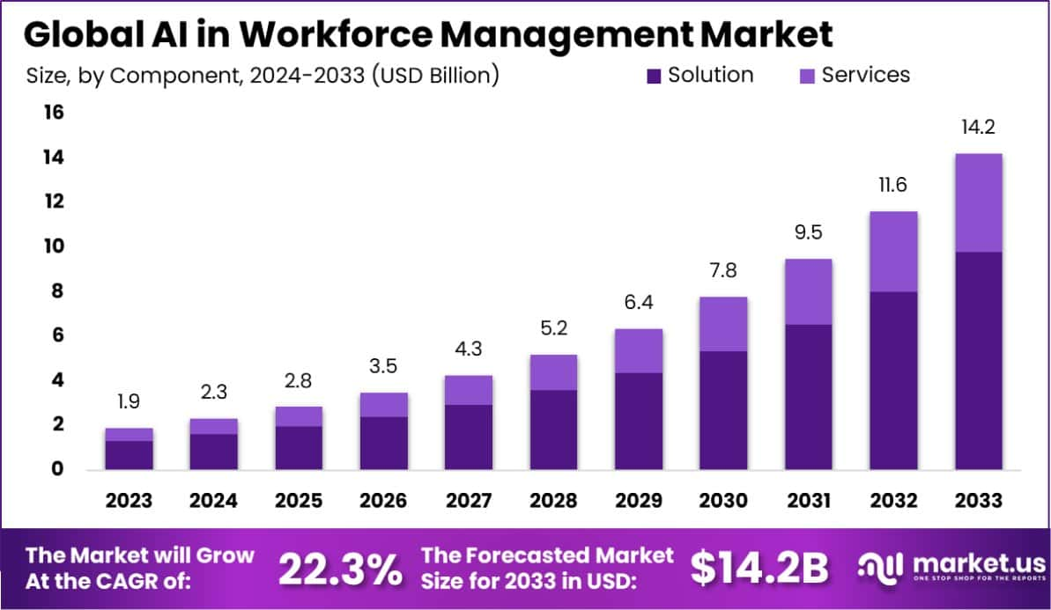
Figure 1: AI in Workforce Management
(Source: Savolainen et al., 2025)
The transformation of workforce AI by is involving the shift of focus from task level execution to a human machine collaboration approach. The integration of AI is expected to replace 50% of the job roles across industries. In order to execute the changes, it is important for organizations to have good strategic approaches. The organizations are needed to shift to skills based architecture (Savolainen et al., 2025). It is important for organizations to explore the existing talent pool by adjusting with the current work environment. The development of AI skills has also become important for the employees to grow in their careers. The presence of AI skills can significantly influence employees to grow in their career. While businesses are needed to adapt enterprise wise development of skills to have presence of an efficient workforce. The introduction of AI is also expected to make significant changes in entry level job roles (Chhibber et al., 2025). This reflects on the need of creating innovative career paths in organizations to help the employees at entry level. The organizations are also required to adopt a holistic approach for developing the skills of employees across the organization.

6.4 Relevant Theories
- Resource-Based View (RBV)
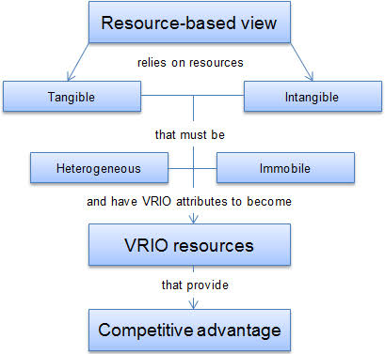
Figure 2: Resource Based View
(Source: Lubis, 2022)
The resource-based review theory states that sustainable competitive advantage in organizations require presence of valuable, rare, inimitable and non-substitutable resources (Lubis, 2022). Regarding this topic, AI capabilities of organizations can be considered as the strategic resources to achieve sustained competitive advantage in the long term.
- Dynamic Capabilities Theory
Based on the resource-based view theory, the dynamic capabilities theory has been developed by expanding the key aspects. This theory emphasizes businesses' abilities of adaptation, integration and reconfiguration of resources for managing business change (Teece et al., 1997). The development of technological capabilities is highly significant for companies in the contemporary era.
- Technology Acceptance Model (TAM)
TAM states that adaptation of new technologies among customers can be understood with a product’s usefulness and perceive ease of use.

7.0 Data Sources and Research Design
In research studies, the data collection method is important to decide on the data analysis method and bring conclusion to a topic. Primary and secondary are the two types of data collection method followed in research studies. This research has considered a secondary data collection method to analyse the impact of AI adoption in workforce transformation and improvement of productivity. The use of secondary data has been significant in the research to pave the way for analysing large volumes of research data (Mazhar et al., 2021). The implications of AI across industries have also been explored efficiently with the incorporation of AI. The specific secondary data analysis source to be followed in the research are journal articles, industry reports, company reports and news sources. The research will also consider some of reputable sources of data such as PwC report, McKinsey report, WEF report, and IBM report. The reason behind considering the sources is authenticity and rigour methodology followed in the study. The use of secondary data has also helped in avoiding high time consumption in data collection (Dale et al., 2025). However, potential risks of bias and sampling issues existed in the collected secondary data in the research.

8.0 Conclusion
It can be concluded that for the business perspectives, the AI implementation of AI is extremely significant mainly as a strategic tool for any business enterprise. The significance of AI technology in the past few years for enhancing the technology operations has claimed competitive advantage. Thus, it could be considered that AI technology has become extremely significant. Thus, the AI has pushed businesses for offering good customer experience.

TASK 2: Critical Reflection on Academic Skills and Professional Identity

1.0 Introduction
With the development of AI, AI Strategic Consultant roles are expected to have significant demand in the market. The increasing integration of AI in businesses has influenced the demand for the role. Using AI, businesses are improving operational efficiency and innovation. In future, I would like to develop a professional career in the role of AI Strategic Consultant. I have focused on evaluating my knowledge as well as skills in this reflection to explore the career path. My areas of improvement for developing my career, and personal development have also been included in the report.

2.0 Reflective Framework
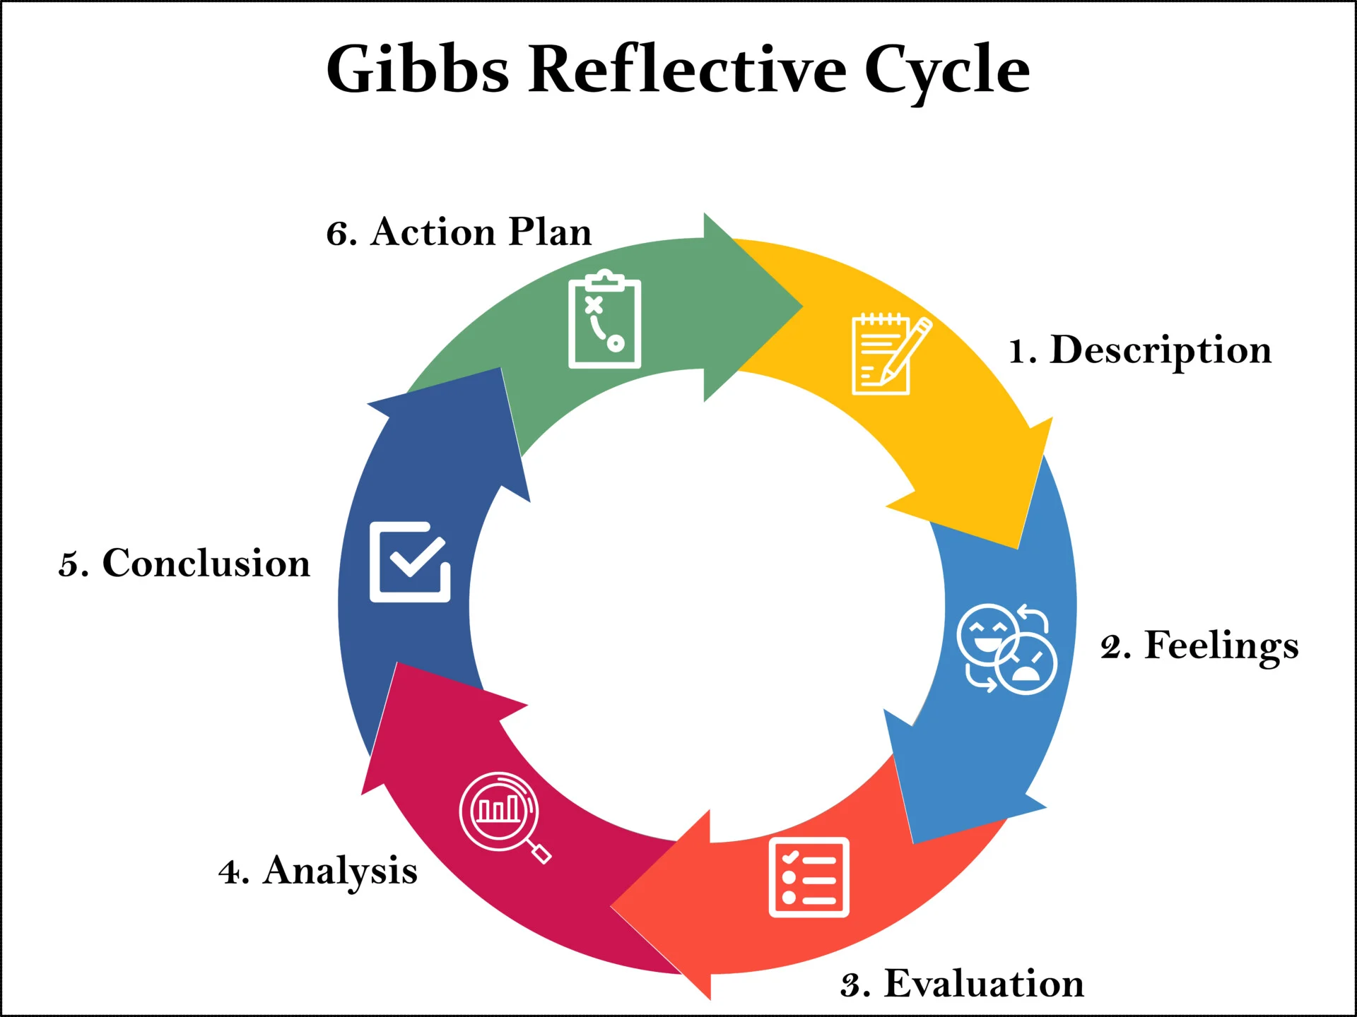
Figure 3: Gibbs reflective cycle
(Source: Simply Psychology, 2025)
In this reflection, the Gibbs Reflective Cycle (1988) has been used to reflect on my professional career and academic growth. The Gibbs reflective cycle has been considered for its high relevancy of reflecting on a situation through six stages which include description, feelings, assessment, analysis, conclusion, and action plan. The use of Gibbs reflective cycle has helped in evaluating my experiences of academic career and future scope of professional career (Coe et al., 2025). It has helped in identifying the areas of improvement to build a strong professional career for me. Use of Gibbs reflective cycle has also helped in assessing my existing capabilities and plan for the personal development plan.

3.0 Self-Evaluation
Taking into account the profession of a Business Analyst which lies in my future, I can state that at the moment I have all the necessary skills which will be helpful in my career development in the future. During my study on the MBA program, as well as during my internship and part-time job, I was able to develop my skills of critical thinking, communication, and time management which helped me to build up my ability to analyze and interpret data rationally. Moreover, I got an opportunity to acquire practical experience in using the following programs: Microsoft Excel, Power BI, SPSS, Tableau which enabled me to analyze and visualize the data from business and make certain decisions based on the results.
However, there are some spheres where I need to improve my skills in order to become a good Business Analyst. First of all, it is necessary to talk about the changing of requirements for business and handling the changes in objectives of the project. The second sphere which needs to be improved is related to the coordination of the expectations of different stakeholders because sometimes their views can contradict each other. Moreover, I need to be more confident in explaining the technical results to non-specialists in other departments. In general, I am ready for my future career but I need to keep on developing constantly.

4.0 Skills Development
In order for me to become an effective Business Analyst, I will have to work towards the improvement of my skills. Through self-analysis, I have realized that there are five skills that require development.
- Business Analysis and Requirements Management: While I have gained some basic knowledge of business analysis techniques through my studies in MBA and from experience, I will need to improve on my skills of acquiring and managing changes in business requirements. This is because organizations are dynamic and, therefore, a Business Analyst will need to be able to analyze changing business requirements.

- Stakeholder Management: Business Analysts regularly interact with managers, clients, technical teams and end users who often have different expectations. I need to improve my ability to build relationships, manage conflicting priorities and facilitate collaboration among diverse stakeholders. Developing stronger negotiation and interpersonal skills will enable me to achieve better project outcomes.
- Communication and Presentation Skills: While I possess good communication skills, I recognise the importance of explaining technical information to non-technical audiences in a simple and understandable manner. Enhancing my presentation, report-writing and active listening skills will improve collaboration and support informed decision-making across departments.
- Advanced Data Analytics: I have practical knowledge of Excel, Power BI, SPSS and Tableau; however, I aim to further strengthen my analytical capabilities by learning advanced data modelling, dashboard development and business intelligence techniques. Strong analytical skills and knowledge will be useful while working on the analysis of data sets and formulating appropriate recommendations.
- Leadership and Change Management: Leadership & Change Management: Since technology and artificial intelligence are used extensively in the organizations, the need for the role of Business Analyst in managing the change process in an organization is becoming very crucial. It is very important for me to develop the necessary skills of leadership and change management to manage the change process.

5.0 Personal Development Plan
To reach my career goal and become an effective Business Analyst, I have elaborated the following development plan which comprises both technical and interpersonal skills. During the first six months, I am going to deepen my knowledge about business analysis by attending some professional courses dedicated to requirements gathering, Agile and business process modeling. Moreover, during the same period of time I am going to develop my data analytics skills by learning some advanced Excel, Power BI, SPSS and Tableau functions.
During one year, I am going to improve my stakeholder management and communication skills by doing group projects, professional presentations and workshops. It is expected to increase my ability to communicate technical information to non-technical stakeholders and raise my skill of team coordination. Also, during this time I am going to find some internships and business projects to implement my theoretical knowledge in practice.
In order to develop my leadership and change management skills, I am going to actively participate in some university projects and collaborate with other people while completing some assignments that require team coordination and solving business problems. To track my development, I will try to get some feedback from my mentors, supervisors and colleagues in relation to achievement of my goals.

6.0 Conclusion
So, this self-reflection has helped me to reveal my advantages and disadvantages regarding the future profession of the Business Analyst. Development of technical, stakeholder management, communication, leadership and analytical skills will make me professionally prepared for my chosen career path.

References
Bharadiya, J. (2023) ‘The impact of artificial intelligence on business processes’, European journal of technology, 7(2), pp.15-25. Available at: https://www.academia.edu/download/123707086/1611.pdf
Bharadiya, J.P., Thomas, R.K. and Ahmed, F. (2023) ‘Rise of artificial intelligence in business and industry’, Journal of Engineering Research and Reports, 25(3), pp.85-103. Available at: https://www.academia.edu/download/123707107/1776.pdf
Chhibber, S., Rajkumar, S.R. and Dassanayake, S. (2025) ‘Will artificial intelligence reshape the global workforce by 2030? A cross-sectoral analysis of job displacement and transformation’, Blockchain, Artificial Intelligence, and Future Research, 1(1), pp.35-51. Available at: https://doi.org/10.70211/bafr.v1i1.178
Coe, R., Waring, M., Hedges, L.V. and Ashley, L.D. eds. (2025) Research methods and methodologies in education. SAGE Publications Limited.
Dale, A., Arber, S. and Procter, M. (2025) Doing secondary analysis. Taylor & Francis.
Enholm, I.M., Papagiannidis, E., Mikalef, P. and Krogstie, J. (2022) ‘Artificial intelligence and business value: A literature review’, Information systems frontiers, 24(5), pp.1709-1734. Available at: https://link.springer.com/article/10.1007/s10796-021-10186-w?trk=public_post_comment-text
Jiang, Y., Li, X., Luo, H., Yin, S. and Kaynak, O. (2022) ‘Quo vadis artificial intelligence?’, Discover Artificial Intelligence, 2(1), p.4. Available at: https://link.springer.com/article/10.1007/s44163-022-00022-8
Loureiro, S.M.C., Guerreiro, J. and Tussyadiah, I. (2021) ‘Artificial intelligence in business: State of the art and future research agenda’, Journal of business research, 129, pp.911-926. Available at: https://doi.org/10.1016/j.jbusres.2020.11.001
Lubis, N.W. (2022) ‘Resource based view (RBV) in improving company strategic capacity’, Research Horizon, 2(6), pp.587-596. Available at: http://journal.lifescifi.com/index.php/RH/article/view/85
Mazhar, S.A., Anjum, R., Anwar, A.I. and Khan, A.A. (2021) ‘Methods of data collection: A fundamental tool of research’, Journal of Integrated Community Health, 10(1), pp.6-10. https://doi.org/10.24321/2319.9113.202101
McKinsey (2024) The state of AI in 2025: Agents, innovation, and transformation. Avaulable at: https://www.mckinsey.com/capabilities/quantumblack/our-insights/the-state-of-ai (Accessed: 07 July 2026).
Perifanis, N.A. and Kitsios, F. (2023) ‘Investigating the influence of artificial intelligence on business value in the digital era of strategy: A literature review’, Information, 14(2), p.85. Available at: https://www.mdpi.com/2078-2489/14/2/85
Ruiz-Real, J.L., Uribe-Toril, J., Arriaza Torres, J.A. and de Pablo Valenciano, J. (2021) ‘Artificial intelligence in business and economics research: Trends and future’, Business Economics and Management (JBEM), 22(1), pp.98-117. Available at: https://www.econstor.eu/handle/10419/317464
Savolainen, I., Ylinen, L., Grönroos, R. and Oksanen, A. (2025) ‘AI transformation in working life: A systematic review of usage and attitudes towards AI among workers’, Digital Business, p.100162. Available at: https://doi.org/10.1016/j.digbus.2025.100162
Sestino, A. and De Mauro, A. (2022) ‘Leveraging artificial intelligence in business: Implications, applications and methods’, Technology analysis & strategic management, 34(1), pp.16-29. Available at: https://www.tandfonline.com/doi/abs/10.1080/09537325.2021.1883583
Simply Psychology (2025). Gibbs Reflective Cycle. https://www.simplypsychology.org/gibbs-reflective-cycle.html.
Soni, N., Sharma, E.K., Singh, N. and Kapoor, A. (2020) ‘Artificial intelligence in business: from research and innovation to market deployment’, Procedia Computer Science, 167, pp.2200-2210. Available at: https://www.sciencedirect.com/science/article/pii/S1877050920307389
Stone, P., Brooks, R., Brynjolfsson, E., Calo, R., Etzioni, O., Hager, G., Hirschberg, J., Kalyanakrishnan, S., Kamar, E., Kraus, S. and Leyton-Brown, K. (2022) ‘Artificial intelligence and life in 2030: the one hundred year study on artificial intelligence’, arXiv preprint arXiv:2211.06318. Available at: https://doi.org/10.48550/arXiv.2211.06318

